BUSINESS REQUIREMENTS DOCUMENT (BRD)
Brand Differentiation & Unique Value Proposition Project
Organization: Haimaline Holistic Harmony
Prepared By: Michon Raquel Cooper
Date: July 4, 2026
Version: 1.7
Version History
Version | Date | Description | Author
1.0 | July 4, 2026 | Initial draft: business case, Five Whys, personas, stakeholder register, requirements inventory, risks/implementation framework, and Appendices A–B (user needs, RTM). | Michon Raquel Cooper
1.1 | July 12, 2026 | Added Appendix C (Process Inventory & Process Maps), Appendix D (Root Cause Fishbone Diagrams), and Appendix E (DOWNTIME Waste Analysis & Improvement Roadmap), with cross-references added in Sections 2.2 and 5. | Michon Raquel Cooper
1.2 | July 15, 2026 | Added Section 2.6 (Recommended Brand Tagline) with rationale and rejected alternate. | Michon Raquel Cooper
1.3 | July 15, 2026 | Added note in Section 2.6 explaining exclusion of "holistic" from the tagline. | Michon Raquel Cooper
1.4 | July 17, 2026 | Added Appendix F (Gap Analysis) synthesizing current-state vs. desired-state gaps across strategy, process, requirements, and DOWNTIME waste categories. | Michon Raquel Cooper
1.5 | July 17, 2026 | Added Appendix G (Stakeholder Analysis Matrix) with power/interest grid and engagement strategies, derived from the Section 3 stakeholder register. | Michon Raquel Cooper
1.6 | July 17, 2026 | Added Appendix H (Communication Plan) defining stakeholder communication requirements, phase-based cadence, key messages, escalation path, and feedback loops. | Michon Raquel Cooper
1.7 | July 20, 2026 | Added Appendix I (SWOT Analysis) synthesizing the business case, Five Whys, personas, survey findings, and Gap Analysis into strengths, weaknesses, opportunities, and threats, with a cross-reference added in Section 2.2. | Michon Raquel Cooper

1. Executive Summary
This Business Requirements Document (BRD) defines the strategic and operational requirements to guide the brand differentiation and Unique Value Proposition (UVP) framework development for Haimaline Holistic Harmony. The organization operates in a highly saturated wellness market where its premium holistic therapies are frequently misperceived as traditional day-spa services or digital self-care apps. This document serves as the foundation for repositioning the company as a trusted, outcome-based provider of personalized preventive health solutions specifically tailored to high-earning, high-performing professionals aged 30–50.

2. Business Case & Problem Analysis

2.1 Business Problem Statement
Haimaline Holistic Harmony is struggling to differentiate itself in an increasingly saturated wellness market, making it difficult to attract and convert high-income professionals aged 30–50 who are seeking meaningful, long-term health transformation. Because the brand's premium holistic therapies are often perceived as comparable to traditional spa services or self-care apps, prospective clients do not fully understand the unique preventive-care benefits and transformative outcomes offered. As a result, the business experiences lower-than-desired brand awareness, slower client acquisition, and reduced client retention, limiting sustainable growth and market positioning.

2.2 Five Whys Root Cause Analysis
A comprehensive ‘Five Whys’ root cause analysis was conducted to uncover the core structural issue limiting business growth:
- Why #1: Why are we struggling to attract and convert high-earning professionals? Because potential clients do not clearly understand how our services differ from other wellness providers.
- Why #2: Why do potential clients not understand how our services differ? Because our messaging does not clearly communicate the unique benefits and outcomes of our holistic therapy approach.
- Why #3: Why does our messaging fail to communicate these unique benefits and outcomes? Because the business has not developed a clearly defined and consistently communicated Unique Value Proposition (UVP).
- Why #4: Why has a clearly defined and consistently communicated UVP not been developed? Because there has been limited research into customer needs, perceptions, and competitor positioning within the wellness market.
- Why #5: Why has there been limited research into customer needs and competitor positioning? Because the business has focused primarily on service delivery and client care rather than strategic branding, market analysis, and long-term marketing planning.
Root Cause: The root cause of the problem is the lack of a clearly defined and research-based Unique Value Proposition supported by strategic brand positioning and customer-focused marketing. This prevents prospective clients from understanding the transformative and preventive-care benefits that differentiate Haimaline Holistic Harmony from traditional spas, wellness centers, and self-care applications.
This root cause analysis is supported by a complementary operational review — a full process inventory, marketing mix and 6M fishbone diagrams, and a Lean DOWNTIME waste assessment — conducted to validate these findings at the process level. See Appendix C (Process Inventory & Process Maps), Appendix D (Root Cause Fishbone Diagrams), and Appendix E (DOWNTIME Waste Analysis & Improvement Roadmap) for full detail. A consolidated Gap Analysis synthesizing these findings is provided in Appendix F (Gap Analysis). A SWOT analysis synthesizing these findings into strengths, weaknesses, opportunities, and threats is provided in Appendix I (SWOT Analysis).

2.3 Desired Outcome Statement
Develop and communicate a compelling Unique Value Proposition (UVP) that clearly positions Haimaline Holistic Harmony as a premium preventive wellness solution rather than a traditional spa or self-care service. By differentiating the brand through its transformative methodology, measurable wellness outcomes, and personalized client experience, the business aims to:
- Increase qualified client bookings by 25–40% within 12 months.
- Improve client retention and repeat-service rates.
- Strengthen brand recognition among high-earning professionals (ages 30–50).
- Establish authority in preventive and holistic wellness.
- Build a predictable client acquisition pipeline that supports long-term business growth.

2.4 Project Scope

In-Scope Elements
- Evaluating current brand positioning and identifying key differentiators.
- Developing a compelling Unique Value Proposition (UVP) and refining cross-channel marketing messages.
- Optimizing digital client touchpoints (website messaging, digital onboarding) to communicate preventive care and outcomes.
- Designing transition frameworks and training internal staff/practitioners to ensure consistent messaging.

Out-of-Scope Elements
- Expanding physical service offerings or modifying therapeutic treatment modalities.
- Opening new brick-and-mortar locations.
- Restructuring core operational or clinical business structures.

2.5 Targeted Customer Personas
To avoid broad, generic day-spa marketing tropes, all requirements are anchored to two highly specific psychological and professional profiles of executive burnout:

Persona 1: “The Redlined Executive” (Corporate Exhaustion)
Profile: Marcus Chen, Age 44, VP of Product Engineering (Tech Sector). Income: $285,000+.
Mindset: “I am running on fumes, but stopping is not an option.”
Pain Points: Severe cognitive/decision fatigue, sleep fragmentation (waking up at 3:00 AM with a racing mind), chronic stress-cortisol pain (lower back, tension headaches).
Buying Behaviors: Extremely time-sensitive, price-insensitive. Demands empirical, logical validation of why a therapy works and seamless one-click digital booking. Hates ‘fluffy’ or overly spiritualized marketing language; views traditional day spas as a waste of productive time.

Persona 2: “The Hyper-Achieving Partner” (High-Anxiety Burnout)
Profile: Sarah Jenkins, Age 36, Junior Partner at Corporate Law Firm. Income: $240,000.
Mindset: “If I drop one ball, the entire tower collapses.”
Pain Points: Chronic sympathetic nervous system activation (fight-or-flight), hyper-vigilance, sensory overload from continuous high-stakes screen exposure, imposter syndrome driven by exhaustion.
Buying Behaviors: Seeks premium, curated spaces that guarantee absolute privacy and discretion. Relies heavily on elite brand prestige and trusted peer recommendations. Frustrated by fragmented paper-based onboarding or crowded waiting rooms; requires structured, recurring preventive plans rather than transactional single appointments.

2.6 Recommended Brand Tagline
Tagline: "Base to Gold: The Haimaline Harmony Effect."
This tagline was developed to give the brand's transformational UVP a memorable, ownable expression, drawing on an elemental-alchemy framing (the transmutation of a base state into a refined one) that is consistent with the founder's broader preventive-wellness positioning. The brand name leads the tagline directly, reinforcing recognition and recall, while "Effect" signals a transformative outcome without reading as a clinical or medical claim.
An earlier candidate, "The Triple H Effect: From Base to Gold," was considered and set aside after a naming review identified overlapping use of "Triple H" by existing wellness-adjacent businesses, as well as an unrelated but established clinical usage of "triple-H therapy" in vasospasm treatment literature. The recommended tagline preserves the "base to gold" transformation narrative — which can also support a future tiered service structure (e.g., Base, Silver, Gold) — while avoiding that naming overlap.
Note on "holistic": The word "holistic" is intentionally omitted from the tagline itself. It is already carried by the business name (Haimaline Holistic Harmony), so repeating it in the tagline would be redundant rather than reinforcing. More importantly, the User Needs Statements in Appendix A show "holistic"/"natural" framing as a real but minority signal (4 of 10 respondents), while the core business problem (Section 2.1) is that prospective clients mistake the brand for a traditional day spa or self-care app. Leading the tagline with "holistic" risks reinforcing that exact misperception rather than the premium, outcome-based, preventive positioning the UVP is built around. "Holistic"/"natural" language remains appropriate in supporting copy (About page, service descriptions) aimed at that segment, but is not recommended for the primary tagline.

3. Stakeholder Register & Matrix
The project involves a diverse ecosystem of primary and secondary stakeholders who influence or are impacted by the brand rollout:
A power/interest grid analysis and corresponding engagement strategies are provided in Appendix G (Stakeholder Analysis Matrix).
Stakeholder Group | Interest / Impact | Influence Level
Business Sponsor / Owner/Founder | High — strategic vision, approval, and profitability & positioning | High
Prospective Clients | High — target audience / end users; core booking drivers | High
Marketing Team/Consultants (SMEs) | High — implementation of campaigns; copy & asset management | High
Brand Strategist | High — UVP development analysis; framework architecture | High
Holistic Therapists | High — service experts; embody brand; client care & loyalty | Medium
Website Developer | Medium — technical; digital conversion; systems execution | Medium
Referral Partners | Medium — external healthcare professionals; validate credibility | Medium
Community Partners | Medium — external local collaborations; visibility expansion | Low

4. Requirements Inventory
The following centralized repository logs all requirements gathered across discovery phases, categorized by type to maintain direct traceability:
ID | Type | Requirement Description | Objective | Priority
BR-01 | Business | Develop clear and compelling Unique Value Proposition (UVP). | Increase differentiation | High
BR-02 | Business | Establish consistent brand messaging across all channels. | Improve brand recognition | High
BR-03 | Business | Increase awareness among high-income professionals 30–50. | Improve acquisition | High
BR-04 | Business | Position business as preventive wellness provider vs. spa. | Strengthen positioning | High
BR-05 | Business | Increase client retention through ongoing education. | Improve customer loyalty | Medium
SR-01 | Stakeholder | Provide formalized, consistent messaging guidelines for marketing staff. | Support marketing campaigns | High
SR-02 | Stakeholder | Provide clinical outcome talking points for practitioners. | Improve client experience | Medium
FR-01 | Functional | Website shall shift content from services to outcome-driven language. | Improve online conversion | High
FR-02 | Functional | Website shall support frictionless, modern calendar booking integration. | Improve client convenience | High
FR-03 | Functional | Website shall seamlessly display privacy-compliant testimonials. | Build trust & authority | High
FR-04 | Functional | Marketing system shall support automated post-session email flows. | Increase engagement | Medium
NFR-01 | Non-Functional | Website user interface must be mobile-responsive and load rapidly. | Reduce user bounce | High
NFR-02 | Non-Functional | Visual identity and tone must project elite brand prestige & privacy. | Reinforce professional asset | High
TR-01 | Transition | Train practitioners and intake staff on using new UVP parameters. | Ensure consistent voice | High
TR-02 | Transition | Audit and replace outdated marketing collateral with updated copy. | Prevent mixed messages | High

5. Risks, Assumptions, & Implementation Framework
Assumptions: The organization will maintain its core whole-person health solutions while strictly altering its external terminology. Stakeholders will participate actively in review sprint cycles.
Risks & Mitigations: Internal messaging adoption variance may occur among individual practitioners. This will be mitigated via mandatory interactive workshops and reference cards. Low discovery response rates will be mitigated by providing premium service credits or booking rewards for client participants.
Phased Rollout Plan: Implementation follows a 3-step sequence: Phase 1 (Core UVP Architecture Validation) → Phase 2 (Website Launch & Digital Onboarding Digitization) → Phase 3 (Email Strategy Deployment & Referral Network Collateral Distribution).
This rollout plan is further supported by a phased process-improvement roadmap (quick wins, foundational build, and scale & sustain — see Appendix E), which sequences the underlying operational fixes identified in the DOWNTIME waste analysis to run alongside the UVP rollout above.
A detailed stakeholder communication plan supporting this rollout — covering cadence, key messages, escalation path, and feedback loops — is provided in Appendix H (Communication Plan).

6. Sign-off and Approvals
By signing below, the authorized stakeholders validate that this document completely and accurately details the requirements necessary to execute the Brand Differentiation and Unique Value Proposition initiative.
Business Owner(Michon Cooper) ________________________________ Date: ______________
Lead Business Analyst (Michon Raquel Cooper): ________________________ Date: ______________
Marketing Lead: ________________________________________________ Date: ______________

APPENDIX A
User Needs Statements — Prioritized & Synthesized (Wellness & Holistic Therapy Survey)

Core Needs
Apply broadly across most respondents.
# | Priority | Statement | Evidence
1 | High | Wellness-conscious adults need affordable, recurring self-care options so that they can manage stress and anxiety without it competing with other financial priorities. | All 10 rated wellness “very/extremely important,” yet all capped spend at ≤$249/month regardless of income.
2 | High | Wellness seekers need providers who treat them as a whole person, not a rushed appointment slot, so that they feel understood rather than processed. | Recurring language: “listening,” “rapport,” “acknowledgment,” plus a direct complaint about 15-minute time limits.
3 | High | Time-constrained professionals need flexible, low-friction scheduling so that wellness doesn't get crowded out by work and caregiving demands. | Lack of time was the #2 barrier overall, tied closely with cost.
4 | Medium | Prospective long-term clients need visible proof of consistency and results early on so that they can justify committing to an ongoing program rather than one-off visits. | “Consistency,” “progress,” and “proven results” all named as trust factors.
5 | Medium | Holistic-minded consumers need clearly non-pharmaceutical, natural-approach options so that they can pursue health improvement in a way that matches their personal values. | 4 of 10 defined “holistic” as “natural”; several explicitly contrasted it with medication.

Reprioritization Notes — Core Needs
- Statements 1–3 are backed by universal or near-universal evidence (10/10, or a top-2 ranked barrier) — these are foundational and should anchor any strategy.
- Statement 4 (proof of results) is important for conversion/retention but is a trust-building lever rather than a baseline need — it matters most after someone is already considering the service.
- Statement 5 (natural/non-pharma) is a real but minority signal (4/10). It's a meaningful segmentation/positioning cue, not a need shared by the whole audience — downgraded from the implied “core” framing to Medium.

Segment-Specific Needs
Apply to a particular respondent group or behavior pattern.
# | Priority | Statement | Evidence
6 | High | Regularly-engaged users need a natural next-tier offering so that their high existing commitment converts into higher-value spend, rather than staying flat. | Weekly/monthly users report the highest likelihood-to-invest scores (4–5).
7 | Medium | Cost-and-coverage-sensitive users need insurance/HSA-FSA compatible options so that out-of-pocket cost stops being the deciding factor. | Insurance coverage raised twice, unprompted, as a specific ask.
8 | Medium | High-income, low-frequency users need a compelling reason beyond affordability — like flexible membership structures or premium relationship quality — so that they engage more often, since cost clearly isn't their limiting factor. | e.g., entrepreneurs using services “every few months” despite $200K+ income.
9 | Low | Privacy-conscious, higher-status users need explicit confidentiality assurances so that they feel safe engaging without reputational exposure. | Confidentiality named as a top trust factor by a single business-owner respondent.

Reprioritization Notes — Segment-Specific Needs
- Statement 6 moved to High: it's the clearest revenue-growth lever in the data — your most committed users are also your most willing to spend more, and there's currently no stated offer to capture that.
- Statement 7 stays Medium: unprompted mentions are a strong signal of latent demand, but it's still only two mentions — worth testing, not yet worth a full build-out.
- Statement 8 stays Medium: interesting and strategically distinct (a segment where cost isn't the lever), but it rests on a single anecdote. Treat as a hypothesis to validate, not a confirmed need.
- Statement 9 stays Low: single respondent, no corroborating pattern. Worth keeping on the radar (especially if targeting executives/business owners) but not enough evidence to act on yet.

Synthesis: What the Data Is Actually Saying

1. Cost sensitivity is universal, but it's not really about being “cheap” — it's about proportional value.
Every single respondent capped spend near the same ceiling regardless of income (Statement 1), yet a high-income subgroup is barely engaging at all despite having no cost barrier (Statement 8). This means “affordability” isn't the deepest need — perceived value relative to price is. Two different segments are hitting two different walls: one is priced out, the other isn't compelled in.

2. The two biggest barriers (cost and time) are structurally linked.
Cost and time-scarcity are tied as the top barriers. A low-friction, flexible-scheduling offer that's also moderately priced would address the two largest obstacles simultaneously — this is likely the single highest-leverage product change available.

3. There's a clear upsell path hiding in plain sight.
Your most loyal users (weekly/monthly) are also your most willing to spend more (Statement 6). Meanwhile, your highest-income users are your least engaged (Statement 8). These are two ends of the same problem: the current offering has no “next tier.” Frequent users have nowhere to go but flat usage; wealthy infrequent users have no reason to come more often. A tiered membership or premium-relationship offer could serve both at once.

4. “Holistic” and “natural” are being used as trust/values signals, not just product descriptors.
Only 4/10 respondents explicitly equated holistic with natural, but the way they used it (contrasting it with medication) suggests it functions as shorthand for “a provider who won't just push a prescription at me.” This connects directly to the “whole person, not a slot” need (Statement 2) — both point to a desire for agency and being taken seriously, not literally to avoiding pharmaceuticals.

5. Trust is built through evidence, not promises.
“Consistency,” “progress,” and “proven results” (Statement 4) — plus insurance/coverage asks (Statement 7) and confidentiality (Statement 9) — are all variations on the same underlying want: de-risking the decision to commit. Whether that's financial risk (insurance), social risk (privacy), or “will this actually work” risk (proof of results), respondents are asking for reassurance before they'll invest further.

Key Tensions to Flag
- Universal cost-capping vs. an income-agnostic upsell opportunity — the data says “everyone caps spend near the same number” and “high earners aren't spending more despite no cost barrier.” These aren't contradictory, but they mean a single pricing strategy won't serve both groups; the high-income segment needs a value lever, not a price lever.
- Evidence strength varies a lot across statements — Statements 1–3 are backed by strong, broad patterns (10/10, top-2 barrier). Statements 8 and 9 rest on one respondent each. Worth being explicit about this when presenting to stakeholders so confidence levels aren't flattened into “9 equally-valid needs.”

Recommended Priority Order for Action
1. Flexible, affordable, low-friction access (Statements 1 + 3) — addresses the two biggest, most universal barriers at once.
2. Whole-person, unhurried service experience (Statement 2) — differentiator that's cheap to act on (e.g., session length, listening-first intake) relative to its impact.
3. Next-tier offering for regular users (Statement 6) — clearest revenue-growth lever with existing evidence.
4. Proof-of-results/consistency signals in marketing and onboarding (Statement 4) — supports conversion for the above.
5. Insurance/HSA-FSA compatibility (Statement 7) — worth piloting given unprompted demand.
6. Natural/non-pharma positioning (Statement 5) and premium offer for high-income infrequent users (Statement 8) — treat as segmentation hypotheses to test further.
7. Confidentiality assurances (Statement 9) — monitor; revisit if you see more executive/business-owner respondents.

APPENDIX B
Requirements Traceability Matrix (RTM)
Need ID | User Need | Req. ID | Derived Requirement | Source / Evidence (Survey) | Respondent Segment | Priority | Verification Method | Status
N-01 | Wellness-conscious adults need affordable, recurring self-care options so that they can manage stress and anxiety without it competing with other financial priorities. | R-01.1 | Core program must be priced at or below $249/month. | 10 of 10 respondents capped monthly spend at ≤$249 regardless of income (Q15). | All respondents | High | Pricing test in follow-up interviews | Open
N-01 |  | R-01.2 | Offer a lower entry tier under $100/month for price-sensitive users. | 5 of 10 respondents selected “less than $100” as their spend ceiling (Q15). | Price-sensitive segment | Medium | A/B test entry-tier pricing | Open
N-02 | Wellness seekers need providers who treat them as a whole person, not a rushed appointment slot, so that they feel understood rather than processed. | R-02.1 | Standard appointment length must exceed typical 15-minute industry slots. | Healthcare professional respondent explicitly criticized 15-minute time slots (Q17). | Healthcare professionals | High | Session-length pilot + satisfaction survey | Open
N-02 |  | R-02.2 | Assign consistent, named provider per client rather than rotating staff. | “Consistency” and “rapport” cited as trust factors (Q14). | All respondents | High | Follow-up interview Q2 (rapport) | Open
N-03 | Holistic-minded consumers need clearly non-pharmaceutical, natural-approach options so that they can pursue health improvement in a way that matches their personal values. | R-03.1 | Marketing and service descriptions must foreground natural, non-pharmaceutical framing. | 4 of 10 respondents defined “holistic therapy” as “natural”; several contrasted with medication (Q12). | Natural-approach segment | Medium | Messaging test / copy review | Open
N-04 | Time-constrained professionals need flexible, low-friction scheduling so that wellness doesn't get crowded out by work and caregiving demands. | R-04.1 | Support online self-scheduling with same-week availability. | “Lack of time” was the #2 barrier overall (Q9). | Working professionals | Medium | Booking-flow usability test | Open
N-04 |  | R-04.2 | Offer on-site or concurrent childcare option for parent clients. | One respondent requested childcare included in the ideal experience (Q18). | Parents / caregivers | Low | Follow-up interview Q3 (healthcare professional) | Open
N-05 | Prospective long-term clients need visible proof of consistency and results early on so that they can justify committing to an ongoing program rather than one-off visits. | R-05.1 | Provide a documented progress-tracking mechanism visible to the client. | “Results” and “progress” named as trust factors (Q14). | All respondents | Medium | Prototype progress-tracker + user testing | Open
N-06 | High-income, low-frequency users need a compelling reason beyond affordability, like flexible membership structures or premium relationship quality, so that they engage more often. | R-06.1 | Design a membership tier bundling advanced technology and flexible scheduling. | $200K+ respondent using services “every few months” requested membership programs and advanced technology (Q10). | High-income, low-frequency | Medium | Follow-up interview Q1–2 (income ceiling test) | Open
N-07 | Regularly-engaged users need a natural next-tier offering so that their high existing commitment converts into higher-value spend. | R-07.1 | Introduce an upsell path from base tier to premium tier for weekly/monthly users. | Weekly/monthly users report highest likelihood-to-invest scores, 4–5 (Q16 cross-tab). | Weekly/monthly users | Low | Usage-frequency segmentation + upsell pilot | Open
N-08 | Privacy-conscious, higher-status users need explicit confidentiality assurances so that they feel safe engaging without reputational exposure. | R-08.1 | Publish a clear confidentiality / discretion policy in onboarding materials. | Business owner respondent named confidentiality as top trust factor (Q14). | Business owners / public-facing roles | Low | Follow-up interview Q2 (confidentiality) | Open
N-09 | Cost-and-coverage-sensitive users need insurance/HSA-FSA compatible options so that out-of-pocket cost stops being the deciding factor. | R-09.1 | Evaluate HSA/FSA eligibility and superbill support for services offered. | Insurance coverage raised twice, unprompted, as a specific ask (Q9, Q14). | Cost-sensitive / insured users | Medium | Legal/finance feasibility review | Open

Legend
- Need ID: Links back to the user needs statement artifact (N-01 to N-09).
- Requirement ID: Unique ID for a derived, testable requirement under that need.
- Source / evidence: Specific survey question(s) and finding supporting this requirement.
- Priority: High = directly tied to the strongest/most consistent finding; Medium = tied to a moderate or single-segment finding; Low = tied to a single respondent or minor signal.
- Verification method: How this requirement should be validated before building — mostly the planned follow-up interviews.
- Status: Open = not yet validated; In review = interview/test scheduled; Validated = confirmed by follow-up data; Rejected = disproven.

APPENDIX C
Process Inventory & Process Maps (Marketing & Client Acquisition)
This appendix summarizes the operational process inventory conducted for Haimaline Holistic Harmony's marketing and client acquisition function, along with current-state (as-is) and future-state (to-be) process maps. This analysis complements the Five Whys root cause analysis in Section 2 by identifying the specific processes underlying each finding.

Process Inventory
Fourteen processes were catalogued across market intelligence, strategy, content, pricing, lead generation, conversion, measurement, and governance.
# | Process | Category | Current State | Priority | Owner | Next Step
1 | Customer/market research | Market intelligence | Exists — wellness survey completed | Medium | Founder | Synthesize findings into a UVP workshop
2 | Competitor analysis | Market intelligence | Missing/partial — not formally documented | Medium | TBD | Audit 3–5 direct competitors' positioning and pricing
3 | UVP development | Strategy & positioning | Missing | High | Founder / marketing lead | Draft UVP from survey insights; test with clients
4 | Brand positioning & guidelines | Strategy & positioning | Missing — no brand guide | High | Marketing lead | Create brand guide once UVP is finalized
5 | Messaging framework (audience-specific) | Content & messaging | Missing — not built around survey motivations | High | Marketing lead | Build messaging pillars around stress relief, sleep, energy
6 | Marketing content creation (web, social, collateral) | Content & messaging | Ad hoc/partial — no content plan | Medium | Marketing lead / contractor | Build a content calendar aligned to the messaging framework
7 | Pricing & package design | Pricing & packaging | Missing — no tiers addressing cost barrier | High | Founder | Design 2–3 tiered packages addressing cost/time barriers
8 | Lead generation / prospecting | Lead gen & nurture | Partial — unclear consistent channel | Medium | TBD | Define 1–2 consistent, repeatable lead channels
9 | Lead nurturing & follow-up | Lead gen & nurture | Unknown/undocumented | Medium | TBD | Build a simple follow-up sequence (email/text)
10 | Website & digital tools (CRM, analytics, booking) | Tools & systems | Not yet assessed | Low-Medium | TBD | Audit current tools; identify CRM/analytics needs
11 | Consultation/sales conversion process | Conversion | Partial — exists but not tied to UVP | High | Founder | Align consultation talking points to the UVP once defined
12 | Marketing KPI tracking & measurement | Measurement | Missing — no tracking system | Medium | TBD | Define 3–5 core KPIs and a simple tracking method
13 | Marketing ownership/staffing | People/governance | Missing — no dedicated role | High | Founder | Decide: hire, outsource, or dedicate existing staff time
14 | Marketing budget planning | Governance | Unknown/undocumented | Medium | Founder | Set an initial marketing budget tied to the pricing plan
Note: Rows 8, 9, and 14 (lead generation, lead nurturing, and budget planning) are inferred gaps rather than confirmed findings — standard components of any client acquisition function not directly named in the Five Whys or survey results, and worth validating.

Process Maps — As-Is and To-Be
Foundation phase — current state: Market research exists but sits disconnected from everything downstream. UVP/brand positioning and pricing don't exist yet, and messaging remains generic rather than targeted to survey findings.
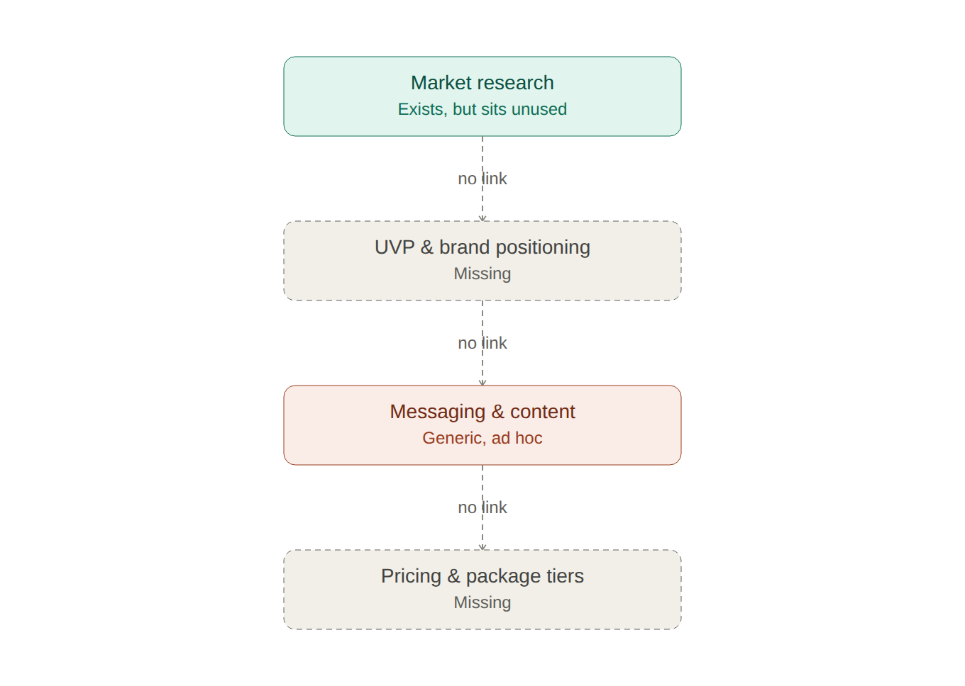
Execution phase — current state: Marketing has no dedicated owner, lead generation and nurture are undocumented, the consultation process runs independently of any UVP, and there is no KPI tracking — so nothing feeds back into research.
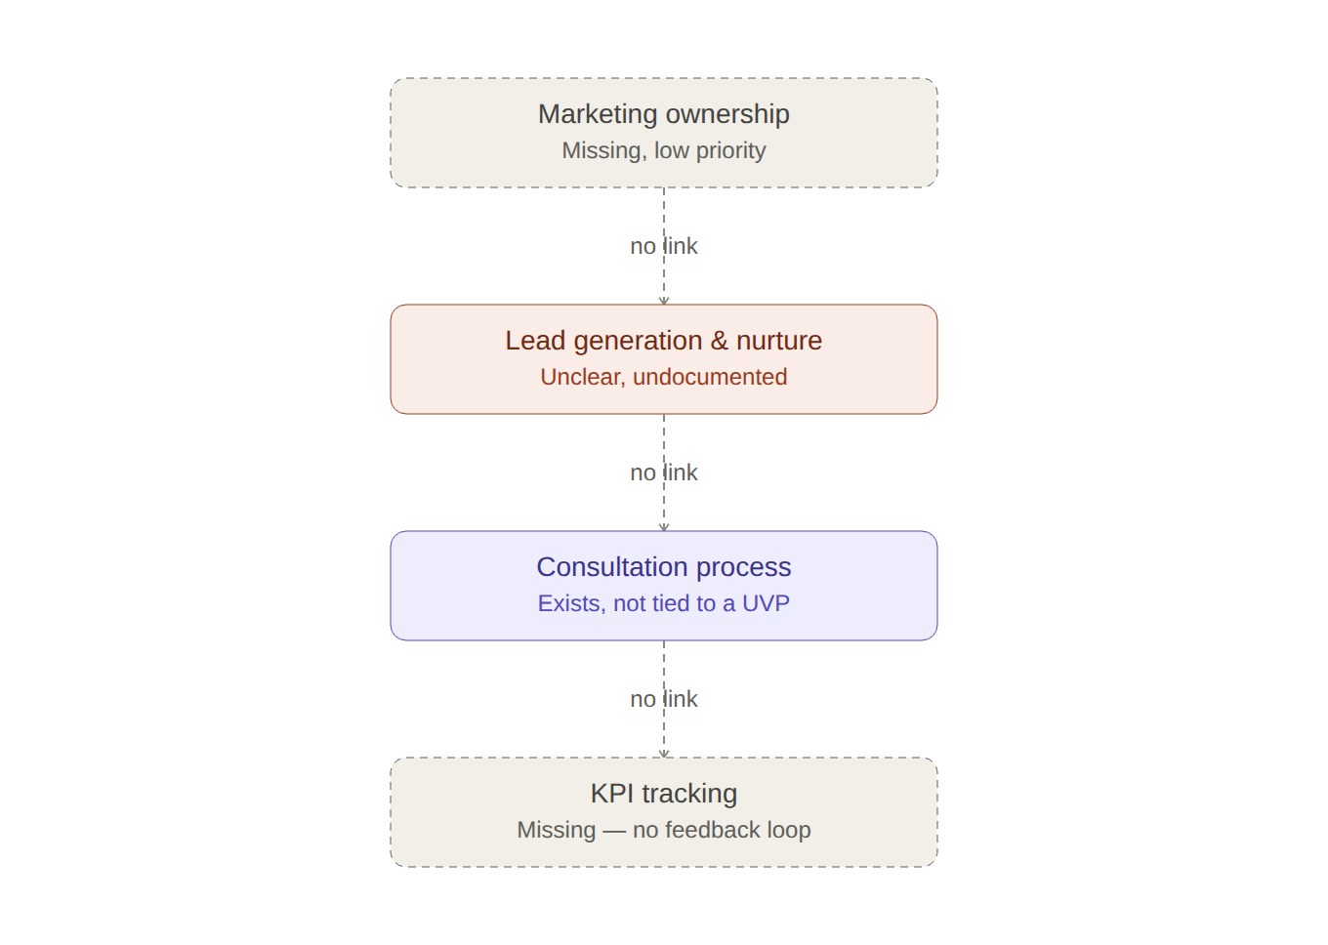
Foundation phase — future state: Ongoing market and competitor research feeds directly into a defined UVP and brand positioning, which shapes a targeted messaging and content framework, which in turn informs pricing and package tiers that address the cost and time barriers identified in the survey.
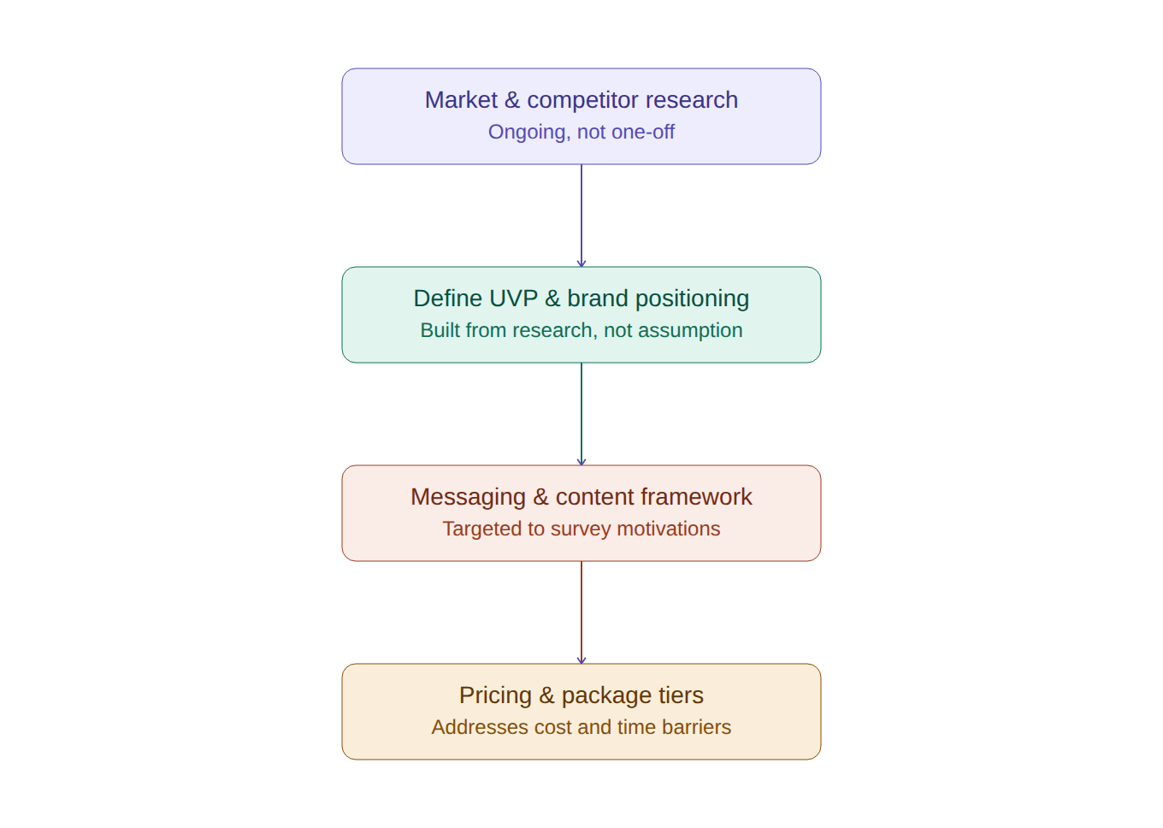
Execution phase — future state: A dedicated marketing owner and CRM support consistent lead generation and nurture, feeding a consultation process aligned to the UVP, with KPI tracking closing the loop by feeding insights back into ongoing research.
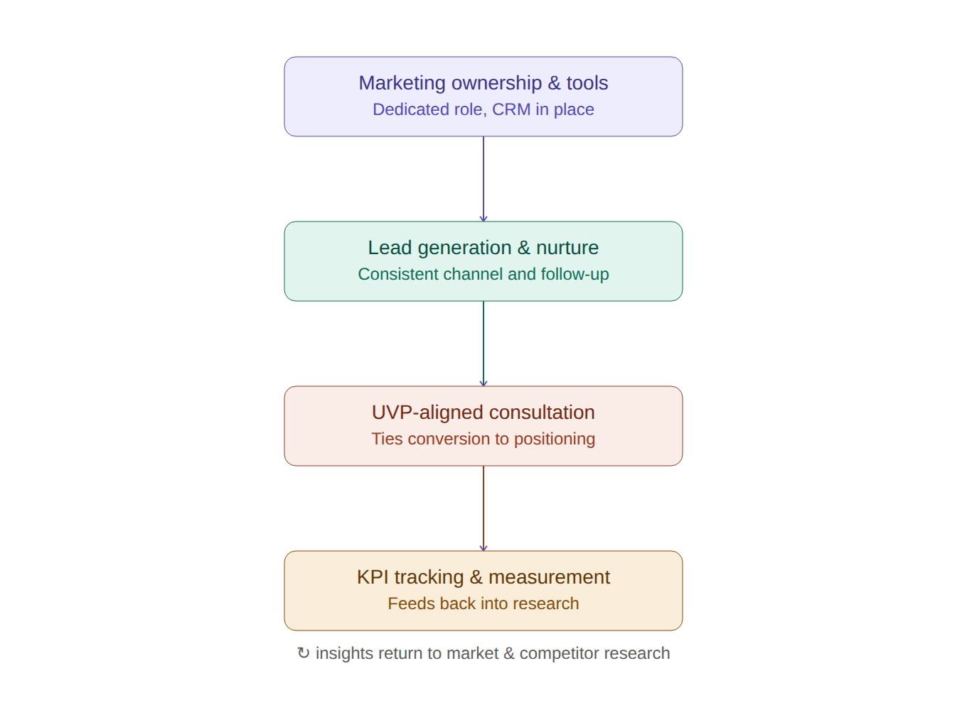

APPENDIX D
Root Cause Analysis — Fishbone Diagrams

Marketing Mix Fishbone (Primary Framework)
This diagram organizes the Five Whys findings using the marketing mix (People, Product, Promotion, Price, Process, Place/Market). Every branch traces directly back to a specific Why from the analysis in Section 2.2. This framework is used as primary because it maps directly onto a marketing/service-based problem.
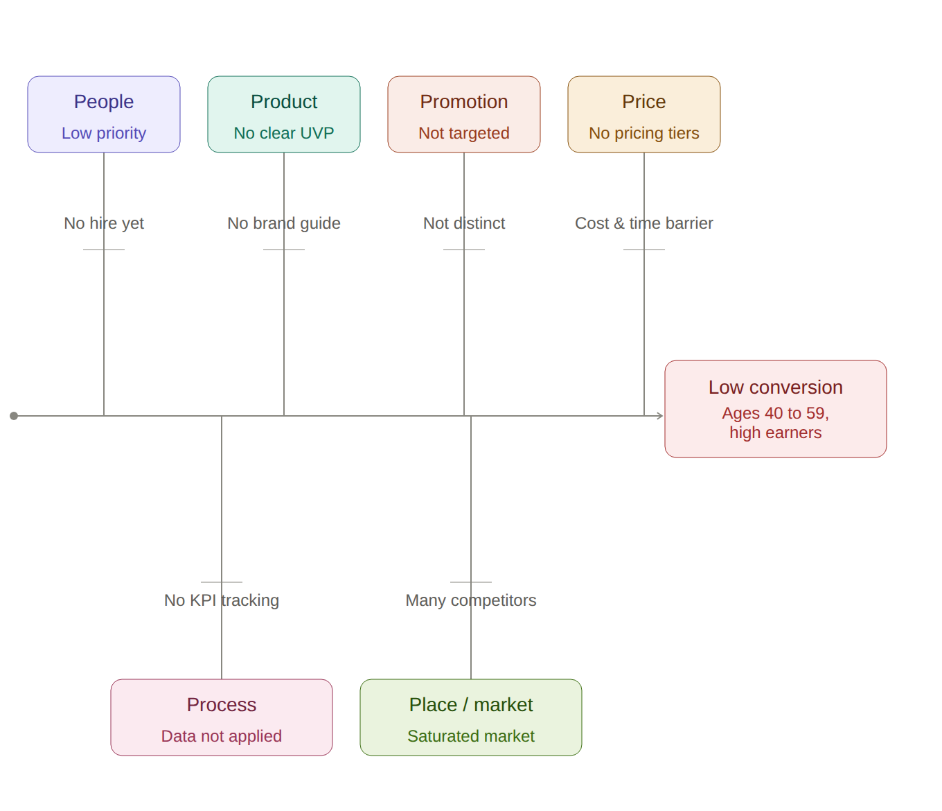

6M Fishbone (Alternate Framework)
The 6M framework (Manpower, Method, Material, Machine, Measurement, Mother Nature) is included as an alternate lens. It originates in manufacturing and quality control, so categories like Machine and Material fit less naturally here, but it still offers a useful completeness check across people, process, tools, data, and external environment.
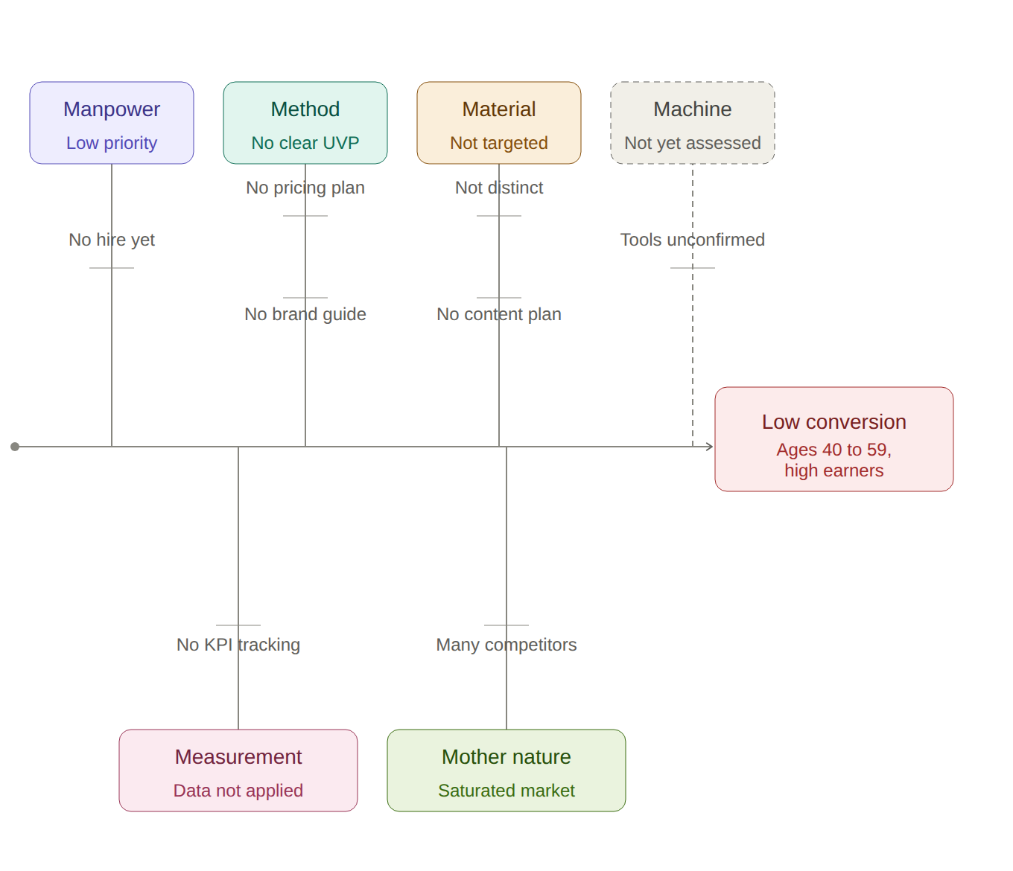

APPENDIX E
DOWNTIME Waste Analysis & Improvement Roadmap

Waste Identification Analysis (DOWNTIME)
Using the Lean DOWNTIME framework (Defects, Overproduction, Waiting, Non-utilized talent, Transportation, Inventory, Motion, Extra-processing), the as-is map's disconnected steps translate into the following categories of waste.
Waste Type | Definition | Where It Shows Up | Process # | Impact
Defects | Effort spent correcting errors or rework | Generic, untargeted messaging leads to mismatched conversations and inconsistent follow-up | 5, 6 | Prospects miss relevance; lower conversion
Overproduction | Producing more than what's needed or usable | Content created without a documented framework, guessing at what will resonate | 6 | Wasted content effort with unclear return
Waiting | Idle time between steps | Leads go cold without a follow-up sequence; survey insights sit idle unapplied | 1, 9 | Lost opportunities, stale insights
Non-utilized talent | Underused knowledge, skills, or data | Wellness survey research collected but never translated into strategy | 1 | Investment in research yields no return
Transportation | Unnecessary movement of information or work | No clear handoff from research findings to messaging and content creation | 1 → 5 → 6 | Insights don't reach the people building content
Inventory | Excess work-in-progress or backlog | Undocumented processes (lead gen, budget) sit as invisible backlog | 8, 14 | No visibility into what's actually happening
Motion | Unnecessary effort or movement in a task | Consultations improvised each time without a consistent, UVP-based script | 11 | Inconsistent client experience, wasted staff effort
Extra-processing | Effort beyond what the client values | Pricing handled ad hoc per client without defined tiers | 7 | Extra negotiation and decision effort per sale

Process Improvement Roadmap
Recommendations are phased by priority and effort from the process inventory, moving from quick wins to foundational build-out to longer-term scale and sustain work. This roadmap runs alongside the 3-phase UVP rollout plan described in Section 5.
Phase 1 — Quick Wins (0–30 days)
- Synthesize existing survey findings into a working UVP draft (addresses Non-utilized talent waste)
- Define 3–5 core marketing KPIs and a simple tracking method
- Decide the marketing ownership model: hire, outsource, or allocate existing staff time
Phase 2 — Foundational Build (30–90 days)
- Finalize the UVP and brand positioning guide
- Build the messaging framework and a content calendar tied to it (addresses Defects and Overproduction waste)
- Design 2–3 pricing/package tiers that address the cost and time barriers
- Align the consultation process to the finalized UVP (addresses Motion and Extra-processing waste)
Phase 3 — Scale & Sustain (90+ days)
- Conduct a formal competitor analysis
- Define consistent lead generation channels and a follow-up/nurture sequence (addresses Waiting waste)
- Audit and select CRM/analytics tools
- Set an annual marketing budget tied to the pricing plan

APPENDIX F
Gap Analysis — Brand Differentiation & UVP Project

F.1 Purpose & Methodology
This Gap Analysis translates findings already documented in this BRD (Five Whys root cause analysis, process inventory, requirements traceability matrix, and DOWNTIME waste assessment) into a single, structured current-state-versus-desired-state view. It makes explicit what exists today, what needs to exist to reach the BRD's desired outcomes (Section 2.3), the size and type of each gap, and the priority in which gaps should be closed.
Four gap categories are assessed:
- Strategic & Brand Gaps — UVP, positioning, and messaging maturity
- Process Gaps — the 14 cataloged marketing/client-acquisition processes (Appendix C)
- Requirements Gaps — open items in the Requirements Traceability Matrix (Appendix B)
- Operational Waste Gaps — DOWNTIME findings (Appendix E)
Priority ratings use the same evidence-strength logic as the rest of this BRD: High = tied to a universal or near-universal finding that directly blocks the desired outcome; Medium = tied to a moderate or single-segment finding; Low = tied to a single data point or minor signal.

F.2 Executive Summary of Gaps
The overarching gap is strategic: Haimaline Holistic Harmony has clinical and service-delivery maturity but no documented Unique Value Proposition, brand positioning guide, or audience-specific messaging framework. This single strategic gap cascades into downstream process gaps (no marketing owner, no pricing tiers, no KPI tracking, no lead-nurture sequence) and leaves client-validated needs (Appendix B) unaddressed in the current offering. Closing the strategic gap first is a prerequisite for closing most process and requirement gaps below; this sequencing is reflected in the phased roadmap in Section F.7.
Gap volume by priority across all four categories:
Category | High | Medium | Low | Total
Strategic & Brand | 3 | 2 | 0 | 5
Process (Appendix C) | 5 | 4 | 1 | 10
Requirements (Appendix B, Open) | 3 | 5 | 3 | 11
Operational Waste (Appendix E) | 3 | 3 | 2 | 8

F.3 Strategic & Brand Gaps
Derived from the Five Whys root cause analysis (Section 2.2) and the Desired Outcome Statement (Section 2.3).
ID | Dimension | Current State | Desired Future State | Priority
GAP-S1 | Unique Value Proposition | No documented, research-based UVP exists. | Clearly defined UVP differentiating preventive, outcome-based care from spa/self-care apps. | High
GAP-S2 | Brand positioning guide | No formal brand guide exists. | Documented positioning guide applied consistently across all channels. | High
GAP-S3 | Audience-specific messaging | Messaging is generic; not built around survey-identified motivations. | Messaging pillars organized around stress relief, sleep, and energy. | High
GAP-S4 | Competitive intelligence | Competitor positioning not formally documented. | Documented audit of 3–5 direct competitors' positioning and pricing. | Medium
GAP-S5 | Pricing & package tiers | No tiered pricing; cost handled ad hoc per client. | 2–3 defined tiers addressing the cost and time barriers identified in the survey. | Medium

F.4 Process Gaps
Condensed from the 14-process inventory in Appendix C. Only processes with a documented gap (i.e., not yet at 'exists and complete') are listed; each links back to its process number for traceability.
ID | Process (Appx. C #) | Current State | Desired State | Priority
GAP-P1 | UVP development (#3) | Missing entirely. | UVP drafted from survey insights and tested with clients. | High
GAP-P2 | Brand positioning & guidelines (#4) | Missing — no brand guide. | Brand guide created once UVP is finalized. | High
GAP-P3 | Messaging framework (#5) | Missing — not built around survey motivations. | Messaging pillars built around stress, sleep, energy. | High
GAP-P4 | Pricing & package design (#7) | Missing — no tiers addressing cost barrier. | 2–3 tiered packages addressing cost/time barriers. | High
GAP-P5 | Marketing ownership/staffing (#13) | Missing — no dedicated role. | Decision made: hire, outsource, or dedicate existing staff time. | High
GAP-P6 | Competitor analysis (#2) | Missing/partial — not formally documented. | 3–5 direct competitors audited for positioning and pricing. | Medium
GAP-P7 | Marketing content creation (#6) | Ad hoc/partial — no content plan. | Content calendar aligned to the messaging framework. | Medium
GAP-P8 | Lead generation/prospecting (#8) | Partial — unclear, inconsistent channel. | 1–2 consistent, repeatable lead channels defined. | Medium
GAP-P9 | Lead nurturing & follow-up (#9) | Unknown/undocumented. | Simple follow-up sequence (email/text) built. | Medium
GAP-P10 | Marketing KPI tracking (#12) | Missing — no tracking system. | 3–5 core KPIs defined with a simple tracking method. | Medium

Not included above: Consultation/sales conversion (#11) and Website & digital tools (#10) are partially functioning today and are treated as dependent on GAP-S1–S3 rather than standalone gaps; Marketing budget planning (#14) is a Low-priority inferred gap tracked in Section F.6.

F.5 Requirements Gaps (from RTM, Appendix B)
Every requirement in the Requirements Traceability Matrix currently carries a status of Open — meaning the underlying user need is validated by survey evidence, but no solution yet exists. Each represents a live gap between a documented client need and current capability.
Need ID | User Need (summary) | Req. ID | Gap (what's missing today) | Priority
N-01 | Affordable, recurring self-care | R-01.1 / R-01.2 | No tier priced at or under $249/mo; no sub-$100 entry tier. | High
N-02 | Treated as whole person, not a rushed slot | R-02.1 / R-02.2 | No minimum session-length standard; no consistent named-provider assignment. | High
N-04 | Flexible, low-friction scheduling | R-04.1 | No online self-scheduling with same-week availability. | Medium
N-03 | Non-pharmaceutical, natural-approach framing | R-03.1 | Marketing/service descriptions don't foreground natural, non-pharma framing. | Medium
N-05 | Visible proof of consistency/results | R-05.1 | No documented progress-tracking mechanism visible to clients. | Medium
N-06 | Next-tier offer for high-income, low-frequency users | R-06.1 | No membership tier bundling advanced tech and flexible scheduling. | Medium
N-09 | Insurance/HSA-FSA compatibility | R-09.1 | HSA/FSA eligibility and superbill support not yet evaluated. | Medium
N-07 | Upsell path for regular users | R-07.1 | No upsell path from base to premium tier for weekly/monthly users. | Low
N-04 | Childcare during appointments | R-04.2 | No on-site or concurrent childcare option. | Low
N-08 | Confidentiality assurance | R-08.1 | No published confidentiality/discretion policy in onboarding materials. | Low

F.6 Operational Waste Gaps (DOWNTIME, Appendix E)
The Lean DOWNTIME assessment identifies waste in the current process flow. Each waste type is, in effect, a gap between the current disconnected process and a desired closed-loop process where research, messaging, pricing, and measurement reinforce one another.
Waste Type | Current State (Gap) | Desired State | Priority
Non-utilized talent | Survey research collected but never translated into strategy. | Research feeds directly into UVP synthesis. | High
Transportation | No handoff from research findings to messaging/content creation. | Documented pipeline from research → messaging → content. | High
Defects | Generic messaging creates mismatched conversations, inconsistent follow-up. | Messaging targeted to survey-identified motivations. | High
Overproduction | Content created without a documented framework. | Content calendar tied to messaging pillars. | Medium
Waiting | Leads go cold with no follow-up sequence; insights sit unapplied. | Defined lead-nurture sequence in place. | Medium
Motion | Consultations improvised each time, no UVP-based script. | Consultation talking points aligned to finalized UVP. | Medium
Inventory | Undocumented processes (lead gen, budget) sit as invisible backlog. | Lead-gen and budget processes documented and visible. | Low
Extra-processing | Pricing negotiated ad hoc per client, no defined tiers. | 2–3 defined pricing tiers reduce per-sale negotiation. | Low

F.7 Prioritized Closure Roadmap
Gap closure is sequenced using the same three-phase structure as this BRD's Process Improvement Roadmap (Section 5 / Appendix E), so this Gap Analysis can be executed alongside the existing UVP rollout plan rather than as a separate initiative.
Phase 1 — Quick Wins (0–30 days)
- Close GAP-S1 / GAP-P1: synthesize survey findings into a working UVP draft
- Close GAP-P5: decide the marketing ownership model (hire, outsource, or allocate)
- Close GAP-P10: define 3–5 core marketing KPIs and a simple tracking method
Phase 2 — Foundational Build (30–90 days)
- Close GAP-S2 / GAP-P2: finalize UVP and brand positioning guide
- Close GAP-S3 / GAP-P3: build the messaging framework and content calendar
- Close GAP-S5 / GAP-P4: design 2–3 pricing/package tiers (addresses N-01, N-06 requirement gaps)
- Close GAP-P9 (Motion/Extra-processing waste): align consultation process to the finalized UVP
Phase 3 — Scale & Sustain (90+ days)
- Close GAP-S4 / GAP-P6: conduct formal competitor analysis
- Close GAP-P8 / GAP-P9: define lead-generation channels and follow-up/nurture sequence
- Audit and select CRM/analytics tools; close remaining Low-priority requirement gaps (N-04 childcare, N-07 upsell path, N-08 confidentiality policy)
- Set an annual marketing budget tied to the finalized pricing plan

F.8 Risk of Not Closing Gaps
If the strategic and process gaps in Sections F.3–F.4 remain open, the requirement gaps in Section F.5 have no mechanism to be resolved — pricing tiers, session-length standards, and progress-tracking cannot be built without a finalized UVP to anchor them. The business would continue to be misperceived as a traditional spa or self-care app (Section 2.1), and the desired outcomes in Section 2.3 (25–40% booking growth, improved retention, brand recognition among high-earning professionals) would remain unreachable.

APPENDIX G
Stakeholder Analysis Matrix

G.1 Methodology
This appendix applies a standard Power/Interest grid to the stakeholder register in Section 3, classifying each stakeholder group by their level of influence (power) over the Brand Differentiation and UVP initiative and their level of interest in (or impact from) its outcome. Where Section 3 rates a stakeholder as 'Medium' on either axis, placement below reflects the practical nature of their role (e.g., strategic decision-makers vs. execution or validation partners) rather than a mechanical midpoint.

G.2 Power/Interest Grid
 | LOW INTEREST | HIGH INTEREST
HIGH  POWER | KEEP SATISFIED  • Website Developer  • Referral Partners | MANAGE CLOSELY  • Business Sponsor / Owner  • Prospective Clients  • Marketing Team/Consultants (SMEs)  • Brand Strategist
LOW  POWER | MONITOR  • Community Partners | KEEP INFORMED  • Holistic Therapists

G.3 Stakeholder Analysis Table
Stakeholder Group | Power/Influence | Interest/Impact | Quadrant | Engagement Strategy
Business Sponsor / Owner/Founder | High | High — strategic vision, approval, profitability & positioning | Manage Closely | Involve in all key decisions; weekly or milestone-based review of UVP and rollout progress.
Prospective Clients | High | High — target audience/end users; core booking drivers | Manage Closely | Validate UVP and messaging directly through follow-up interviews and pilot testing before full rollout.
Marketing Team/Consultants (SMEs) | High | High — implementation of campaigns; copy & asset management | Manage Closely | Full involvement in messaging framework and content calendar development; regular two-way check-ins.
Brand Strategist | High | High — UVP development analysis; framework architecture | Manage Closely | Co-own UVP and brand positioning guide deliverables; joint sign-off before Phase 2 launch.
Holistic Therapists | Medium | High — service experts; embody brand; client care & loyalty | Keep Informed | Share finalized UVP and messaging via training workshops; collect feedback from client-facing experience.
Website Developer | Medium | Medium — technical; digital conversion; systems execution | Keep Satisfied | Provide clear functional requirements (FR-01–FR-03); check in at each build milestone, avoid over-involvement in strategy discussions.
Referral Partners | Medium | Medium — external healthcare professionals; validate credibility | Keep Satisfied | Share finalized positioning once validated; maintain periodic relationship touchpoints without heavy involvement in planning.
Community Partners | Low | Medium — external local collaborations; visibility expansion | Monitor | Light-touch updates only (e.g., newsletter or annual check-in); no active involvement required.

G.4 Engagement Strategy Summary by Quadrant
Manage Closely (High Power, High Interest)
These stakeholders can make or break the initiative and are directly affected by it. Engage fully, involve in key decisions, and maintain frequent two-way communication throughout all three rollout phases.
Keep Satisfied (High Power, Lower Interest)
These stakeholders hold execution or validation power but are not personally invested in the outcome. Keep them sufficiently informed and satisfied to maintain their support, without consuming their time on strategic detail they don't need.
Keep Informed (Lower Power, High Interest)
These stakeholders care about the outcome and are affected by it day to day, but do not hold strategic decision-making power. Provide adequate information and channels for feedback; they may become more influential as the rollout progresses (e.g., therapist buy-in directly affects messaging consistency, per TR-01).
Monitor (Lower Power, Lower Interest)
Minimal effort is required. Monitor for any change in status (e.g., a community partner becoming a referral source) but avoid over-communicating.

APPENDIX H
Communication Plan

H.1 Purpose & Approach
This appendix defines who needs what information, through what channel, how often, and who owns delivering it throughout the Brand Differentiation and UVP initiative. It operationalizes the Power/Interest quadrants established in Appendix G (Stakeholder Analysis Matrix): stakeholders in 'Manage Closely' receive the most frequent, detailed, two-way communication, while 'Monitor' stakeholders receive only light-touch updates. Communication is further sequenced against the three-phase rollout plan defined in Section 5 and Appendix E.

H.2 Stakeholder Communication Requirements
Stakeholder | Quadrant | Key Information Needs | Channel | Frequency | Owner
Business Sponsor / Owner/Founder | Manage Closely | UVP drafts, brand guide approval, budget/KPI review, milestone sign-off | Review meeting + written summary | Weekly (Phase 1–2); bi-weekly (Phase 3) | Brand Strategist / Lead BA
Prospective Clients (survey/pilot group) | Manage Closely | UVP & messaging validation requests, pricing pilot invitations | Email + follow-up interview | At each validation gate | Marketing Lead
Marketing Team/Consultants (SMEs) | Manage Closely | Messaging framework, content calendar, brand guide, campaign specs | Working sessions + shared workspace | Weekly | Marketing Lead
Brand Strategist | Manage Closely | Research findings, positioning decisions, sign-off checkpoints | Working sessions + deliverable review | Weekly (Phase 1–2) | Founder / Lead BA
Holistic Therapists | Keep Informed | Finalized UVP/messaging, consultation talking points, training schedule | Training workshops + reference cards | Milestone-based + monthly touch-base | Practice Manager / Marketing Lead
Website Developer | Keep Satisfied | Functional requirements (FR-01–FR-03), brand assets, testing feedback | Written specs + milestone check-in | At each build milestone | Marketing Lead
Referral Partners | Keep Satisfied | Finalized positioning summary, updated collateral | Email update + relationship call | Quarterly / at major milestones | Founder
Community Partners | Monitor | High-level brand and positioning updates | Newsletter / annual check-in | Annually or ad hoc | Founder

H.3 Communication Cadence by Rollout Phase
Aligned to the phased rollout in Section 5 (UVP rollout) and Appendix E (process-improvement roadmap).
Phase | Primary Audience | Key Message | Cadence
Phase 1 — Core UVP Architecture Validation / Quick Wins (0–30 days) | Business Sponsor, Brand Strategist, Marketing Team | UVP draft synthesis from survey findings; KPI definition; marketing ownership decision | Weekly working sessions
Phase 2 — Website Launch & Digital Onboarding / Foundational Build (30–90 days) | + Website Developer, Holistic Therapists | Finalized UVP and brand guide; functional requirements handoff; practitioner training rollout | Bi-weekly milestone reviews + training workshops
Phase 3 — Email Strategy Deployment & Referral Network / Scale & Sustain (90+ days) | + Referral Partners, Community Partners | Rollout results, updated collateral distribution, ongoing KPI reporting | Quarterly updates + annual check-ins

H.4 Key Messages by Audience
Messaging content is drawn directly from Section 2.5 (Targeted Customer Personas) and Section 2.6 (Recommended Brand Tagline), so all external communication stays consistent with the approved UVP.
Prospective Clients — "The Redlined Executive" (Persona 1)
Lead with empirical, outcome-based language (no 'fluffy' or spiritualized phrasing); emphasize one-click booking and time efficiency; anchor to the tagline "Base to Gold: The Haimaline Harmony Effect."
Prospective Clients — "The Hyper-Achieving Partner" (Persona 2)
Lead with privacy, discretion, and structured recurring plans rather than transactional single visits; emphasize elite brand prestige and peer trust.
Internal Team (Therapists, Marketing, Front-of-House)
Consistent voice and UVP-based consultation talking points per requirement TR-01; reinforce why messaging changed (root cause in Section 2.2) so the team can speak to it confidently, not just recite it.
Referral Partners & Community Partners
High-level positioning summary only — outcome-based preventive care for high-earning professionals — without internal operational detail (pricing tiers, KPI targets, etc.).

H.5 Escalation Path
Issue Type | First Point of Contact | Escalates To
Day-to-day messaging/content questions | Marketing Lead | Brand Strategist
UVP or brand positioning decisions | Brand Strategist | Business Sponsor / Owner
Budget, scope, or timeline changes | Brand Strategist | Business Sponsor / Owner
Technical/website issues | Website Developer | Marketing Lead
Practitioner messaging inconsistency | Practice Manager | Marketing Lead

H.6 Feedback & Reporting Loops
Feedback flows back into the research base identified in Appendix C's future-state process map, closing the loop that the current-state map (Appendix C) shows is currently broken (research findings never reaching messaging and content creation).
- Marketing KPI tracking (3–5 core KPIs, per Appendix E Phase 1) reported to the Business Sponsor monthly once established.
- RTM verification methods (Appendix B) — follow-up interviews, A/B tests, usability tests — feed validated/rejected status updates back to the Brand Strategist and Marketing Lead.
- Practitioner feedback from client-facing experience (Holistic Therapists) is collected during monthly touch-bases and routed to the Marketing Lead for messaging refinement.
- Referral and community partner feedback is captured informally during quarterly/annual check-ins and logged for the next messaging review cycle.

APPENDIX I
SWOT Analysis
This appendix synthesizes the business problem statement (Section 2.1), Five Whys root cause analysis (Section 2.2), customer personas (Section 2.5), wellness survey findings (Appendix A), and Gap Analysis (Appendix F) into a Strengths, Weaknesses, Opportunities, and Threats assessment, providing a consolidated view of the organization's current position ahead of the brand differentiation and UVP rollout.

I.1 Strengths
- Established clinical and service-delivery maturity — the operational and therapeutic foundation is already in place; the gap is strategic, not clinical (Appendix F.2)
- Two well-defined, high-value target personas (“The Redlined Executive” and “The Hyper-Achieving Partner”) with clearly documented pain points and buying behaviors (Section 2.5)
- A recommended, ownable brand tagline (“Base to Gold: The Haimaline Harmony Effect”) already developed, with a naming-conflict review completed (Section 2.6)
- Direct wellness-survey evidence of trust signals already associated with the brand’s holistic/natural positioning (Appendix A, Synthesis #4)
- High-earning target segment is largely price-insensitive once value is demonstrated, supporting premium positioning (Section 2.5, Persona 1)

I.2 Weaknesses
- No documented, research-based Unique Value Proposition exists, which is the root cause of the broader differentiation problem (Section 2.2, GAP-S1)
- No formal brand positioning guide or audience-specific messaging framework, so messaging remains generic rather than targeted (GAP-S2, GAP-S3)
- No tiered pricing structure; cost is handled ad hoc per client, leaving the cost/time barrier identified in the survey unaddressed (GAP-S5)
- No dedicated marketing ownership, KPI tracking, or lead-nurture sequence, so there is no consistent mechanism to execute or measure a repositioning effort (Appendix F.4)
- Premium holistic therapies are frequently misperceived as traditional day-spa services or self-care apps, undermining perceived value (Section 2.1)

I.3 Opportunities
- A clear, evidence-backed upsell path: the most loyal users are also the most willing to spend more, while high-income users are the least engaged — a tiered membership/premium offer could serve both (Appendix A, Synthesis #3)
- Cost and time-scarcity are structurally linked as the top two barriers, meaning a single flexible, moderately-priced access offer could resolve both simultaneously (Appendix A, Synthesis #2)
- Proof-of-results and consistency signals are explicitly requested by respondents, creating a low-cost, high-trust marketing lever once a UVP is defined (Appendix A, Synthesis #5)
- Insurance/HSA-FSA compatibility shows unprompted demand and is worth piloting as a differentiator (Appendix A, Recommended Priority Order, item 5)
- Closing the single strategic UVP gap is a prerequisite for closing most downstream process and requirement gaps, meaning one focused investment unlocks broad downstream progress (Appendix F.2)

I.4 Threats
- Continued misperception as a traditional spa or self-care app if the strategic gap remains open, keeping desired outcomes (25–40% booking growth, improved retention, brand recognition) out of reach (Appendix F.8)
- Internal messaging adoption variance among practitioners during rollout, which could dilute a newly defined UVP if not actively managed (Section 5, Risks & Mitigations)
- Low discovery/survey response rates limiting the evidence base for future decisions if participation incentives are not sustained (Section 5, Risks & Mitigations)
- A saturated wellness market where competitors’ positioning and pricing are not yet formally tracked, risking reactive rather than proactive differentiation (GAP-S4)
- Uneven evidence strength across survey findings (some needs backed by only one respondent) risks over-indexing on thin signals if not explicitly flagged to stakeholders (Appendix A, Key Tensions)

