Results
Behavioral measures
Behavioral assessments included motor activity (open field), hindlimb clasp, and recognition memory tests (novel object and spatial object recognition). PAMP treatment reduced motor activity in the open field, as measured by decreased total distance traveled (F(1, 62) = 10.673, p = 0.002, η_{p}² = 0.147, 95% CI [0.014, 0.379]) and reduced basic movement activity (F(1, 62) = 9.936, p = 0.002, η_{p}² = 0.138, 95% CI [0.013, 0.348]; Table 1). This hypoactivity occurred in both PS19 and Non-Tg mice (Fig 3A, B), indicating a treatment effect independent of genotype. PS19 mice showed elevated distance traveled compared to Non-Tg mice (F(1, 62) = 4.135, p = 0.046, η_{p}² = 0.063, 95% CI [0.001, 0.248]), regardless of treatment (Fig 3A). For the hindlimb clasp measure of spinal degeneration, there was an expected effect of genotype (F(1, 52) = 7.175, p = 0.010, η_{p}² = 0.121, 95% CI [0.003, 0.366]) with greater abnormal clasping behavior in the PS19 mice, but no effect of treatment or interaction (Fig 3C). Notably, none of the included mice exhibited a complete lack of hindlimb splaying behavior, which would be a precursor to hindlimb paralysis. Neither recognition task (NOR and SOR) nor the open field measures of fine movement and rearing showed significant genotype or treatment effects (all p > 0.05; Table S1).
Fig 3. Significant effects of treatment and genotype on distance traveled (A), treatment on basic movement (B) and genotype on hind limb clasping (C). Behavioral data from PS19 and Non-Tg mice following systemic PAMP or Vehicle treatment. (A) Total distance traveled in the open field behavioral test. A significant main effect of genotype (p = 0.046) reflected PS19-related hyperactivity, and a significant main effect of treatment (p = 0.002) reflected PAMP-induced hypoactivity. (B) Basic movement activity. A significant main effect of treatment (p = 0.002) revealed reduced activity in PAMP-treated mice compared to Vehicle controls. (C) Hindlimb clasping scores. A significant main effect of genotype was observed, with PS19 mice demonstrating increased clasping deficits (p = 0.010). No significant genotype × treatment interactions were observed for any measure (all p > 0.05). Data are presented as median with IQR. Total distance traveled and basic movement activity: PS19 PAMPs n = 15, PS19 Vehicle n = 15, Non-Tg PAMPs n = 19, and Non-Tg Vehicle n = 17; Hindlimb clasping: PS19 PAMPs n = 12, PS19 Vehicle n = 13, Non-Tg PAMPs n = 15, and Non-Tg Vehicle n = 16. Main effects and interactions were assessed using ART-ANOVA.

Table 1. ART-ANOVA main effects and interaction results for open field measures (total distance and basic movement) and hindlimb clasp.
Measure | Comparison | F-value (df) | p-value | η_{p}² | 95% CI
Total Distance | Genotype | 4.135 (1, 62) | 0.046 | 0.063 | [0.001, 0.248]
 | Treatment | 10.673 (1, 62) | 0.002 | 0.147 | [0.014, 0.379]
 | Interaction | 0.012 (1, 62) | 0.915 | < 0.001 | [0.000, 0.097]
Basic Movement | Genotype | 2.391 (1, 62) | 0.127 | 0.037 | [0.000, 0.195]
 | Treatment | 9.936 (1, 62) | 0.002 | 0.138 | [0.013, 0.348]
 | Interaction | 0.389 (1, 62) | 0.535 | 0.006 | [0.000, 0.118]
Hindlimb Clasp | Genotype | 7.175 (1, 52) | 0.010 | 0.121 | [0.003, 0.366]
 | Treatment | 1.433 (1, 52) | 0.237 | 0.027 | [0.000, 0.207]
 | Interaction | 0.603 (1, 52) | 0.441 | 0.011 | [0.000, 0.178]
F, F-ratio; df, degrees of freedom; p, p-value; η_{p}², partial eta-squared; CI, confidence interval (bootstrapped, 5,000 resamples). Bold values indicate statistical significance (p < 0.05). Total Distance and Basic Movement: PS19 PAMPs n = 15, PS19 vehicle n = 15, Non-Tg PAMPs n = 19, and Non-Tg vehicle n = 17; Hindlimb clasp: PS19 PAMPs n = 12, PS19 vehicle n = 13, Non-Tg PAMPs n = 15, and Non-Tg vehicle n = 16.

Histological measures of phosphorylated tau and total human tau
We measured phosphorylated tau in the PS19 mice with the antibody AT8, which recognizes tau phosphorylated at Ser202/Thr205. Non-Tg mice were not stained for AT8 or HT7 (see materials and methods); we therefore report PS19 mice only. Whole hemisphere images of horizontal sections showed high levels of AT8 staining in the hippocampus, posterior (entorhinal) cortex, and anterior cortex (Fig 4A, B). Low levels of staining were found in the striatum and thalamus, and staining was present in some brainstem structures. The positively stained forebrain regions correspond to areas known to develop neurofibrillary tangles (NFTs) in humans with AD (Braak & Braak, 1991). P-tau (AT8) accumulation in the whole hemisphere, measured as percentage of area stained, was significantly elevated in PAMP-treated mice (Mdn = 0.286) compared to vehicle (Mdn = 0.094; MWU p = 0.002; Cliff’s Δ = 0.602, 95% CI [0.301, 0.847]; Fig 4C).
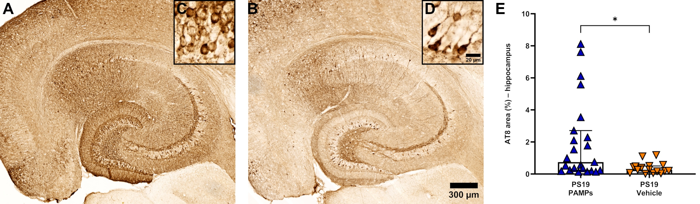Fig 5. Systemic PAMP treatment increases hippocampal AT8 p-tau deposition in PS19 mice. Representative hippocampal sections showing AT8 in (A) PS19 PAMPs and (B) PS19 Vehicle mice. Scale bar = 300 µm. (C, D) Enlarged hippocampal insets indicating neuronal somatodendritic tau accumulation and neurofibrillary-like inclusions. Inset scale bar = 20 µm. (E) Quantification of AT8 percent area showing significantly elevated levels in PS19 PAMPs compared to PS19 Vehicle (p = 0.015). Data are presented as median with IQR. PS19 PAMPs n = 23 and PS19 Vehicle n = 16. Group differences were assessed using MWU
Fig 4. Systemic PAMP treatment increases whole hemisphere AT8 p-tau pathology in PS19 mice. Representative whole hemisphere sections showing AT8 in (A) PS19 PAMPs and (B) PS19 Vehicle mice. Scale bar = 750 µm. (C) Quantification of AT8 percent area showing significantly elevated levels in PS19 PAMPs compared to PS19 Vehicle (p = 0.002). Data are presented as median with IQR. PS19 PAMPs n = 22 and PS19 Vehicle n = 16. Group differences were assessed using MWU.
We further examined p-tau staining restricted to the hippocampus, a region known to exhibit early tau associated pathology in AD. AT8 staining was observed throughout the hippocampus, with the highest density in the CA1, subiculum, and dentate gyrus hilus (Fig 5A, B). Staining was also dense in the entorhinal cortex (left border of images). In the enlarged insets, staining filled neuronal somata and dendrites (Fig 5C, D). PAMP treatment significantly elevated AT8 (Mdn = 0.748) compared to vehicle (Mdn = 0.270; MWU p = 0.015; Cliff’s Δ = 0.465, 95% CI [0.133, 0.745]; Fig 5E).
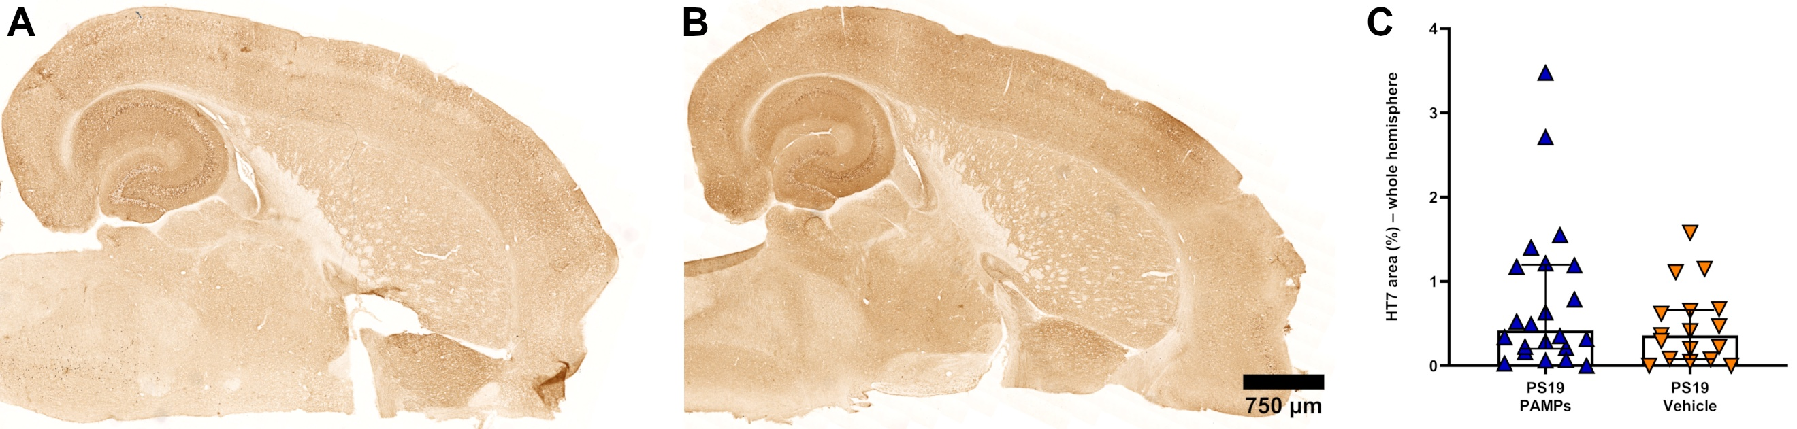 Fig 6. Systemic PAMP administration does not alter whole hemisphere HT7 total tau levels in PS19 mice. Representative whole hemisphere sections showing HT7 in (A) PS19 PAMPs and (B) PS19 Vehicle mice. Scale bar = 750 µm. (C) Quantification of HT7 percent area showing no significant difference in PS19 PAMPs compared to PS19 Vehicle (p = 0.357). Data are presented as median with IQR. PS19 PAMPs n = 22 and PS19 Vehicle n = 17. Group differences were assessed using MWU.
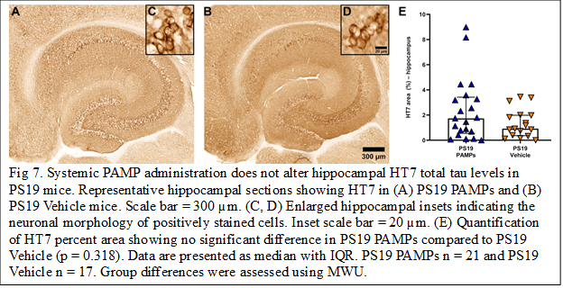
In addition to pathological forms of tau, we also examined the effects of PAMPs on levels of total tau. The HT7 antibody is specific for human tau of all types regardless of phosphorylation status. When examined in the whole hemisphere sections, the pattern of staining was generally more uniform than in the AT8 labeled sections (Fig 6A, B). Unlike AT8, staining in the cortices was comparable to that found in the brainstem and striatal regions. In contrast to AT8, PAMP treatment did not significantly alter HT7 immunoreactivity in the whole hemisphere (MWU p = 0.357; Cliff’s Δ = 0.174, 95% CI [-0.198, 0.519]; Fig 6C).
Within the hippocampus, HT7 staining was most dense in the neuronal layers of the dentate gyrus, CA1, and CA3 regions (Fig 7A, B). HT7-labeled cells had morphology consistent with neurons (Fig 7C, D). However, unlike AT8, PAMP treatment did not significantly affect HT7 immunoreactivity (MWU p = 0.318; Cliff’s Δ = 0.190, 95% CI [-0.182, 0.543]; Fig 7E).

Histological measures of neuroinflammation
To estimate the glial activation responses, we measured MHC II, a marker of microglia activated to present antigens, glial fibrillary acidic protein (GFAP), a marker of astrocyte reactivity, and CD68, a marker of microglial activation associated with increased phagocytosis.
MHC II immunostaining varied markedly among mice, both within and between groups, with sparse labeling throughout much of the brain interspersed with clustered staining in the
Fig 8. MHC II immunoreactivity in the hippocampus demonstrates a genotype × treatment interaction. Representative hippocampal sections showing MHC II in (A) PS19 PAMPs, (B) PS19 Vehicle, (C) Non-Tg PAMPs, and (D) Non-Tg Vehicle mice. Scale bar = 300 µm. (E–H) Enlarged hippocampal insets showing the morphology of MHC II-labeled microglia. Inset scale bar = 20 µm. (I) Quantification of MHC II percent area revealed a significant genotype × treatment interaction (p = 0.012). Post-hoc analysis demonstrated significantly elevated MHC II in PS19 PAMPs compared to both PS19 Vehicle (p < 0.001) and Non-Tg PAMPs (p < 0.001). PS19 Vehicle also showed significantly elevated MHC II compared to Non-Tg Vehicle (p = 0.041), and Non-Tg PAMPs showed significantly elevated MHC II compared to Non-Tg Vehicle (p = 0.016). Data are presented as median with IQR. PS19 PAMPs n = 22, PS19 Vehicle n = 19, Non-Tg PAMPs n = 22, and Non-Tg Vehicle n = 19. Main effects and interactions were assessed using ART-ANOVA. Significant genotype × treatment interactions were followed by ART-C with Holm correction.

